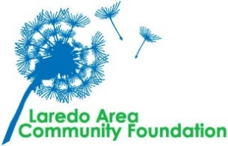
 | Scholarship Requested:
o | Lance Corporal David Lee Espinoza Scholarship
Application deadline: April 19, 2024 at 5 PM
Requirements:
- Student from El Cenizo preferred
- The student must meet the federal guidelines of a financially disadvantaged student based on the Free Application for the Federal Student Aid.
- This is a one-time, non-renewable scholarship.

Applicant Information
Full Name |  |  |  |  | DOB
 | Last First MI
Address
 | Street Address |  |  |  | Apartment/Unit
 | City |  |  |  | Zip Code
Phone | Email
School
GPA | Class Size | Rank | SAT |  | ACT
 |  |  | Math | English Writing
*Submit official high school transcript or if enrolled in college, an official college transcript

Matriculation Information
University Attending
Major
Enrollment Date
*Submit proof of acceptance with application
Ple

Financial Information
Number of people in family | Ages of siblings
Family Income

FAFSA Application completed? o Yes o No
Student Employer |  | Hours Worked per week

Extracurricular Activities
Total Community Service Hours | *Please include verification from school
List of Clubs & Organizations including years of membership, i.e. 2022-2024

*Submit a 1 page essay identifying your community’s greatest need and how you would like to see it addressed
*Submit a letter of recommendation from a teacher, counselor or employer

Submit application and required additional items (designated with a *) to laredofoundation@gmail.com.
Please use pdf format to submit application and required documents and attach to email.

